The University of Lahore 
Department of Computer Science & IT
Final Term Examination
Fall - 2023
Course Title: | Programming Fundamentals | Course Code: | CS02115 | Credit Hours: | 4
Course Instructors: | Dr. Nadeem Iqbal, Mr. Sardar Waqar, Mr. M. Awais, Mr. Majid Hussain, Mr. Ahmad Zia | Program Name: | BSCS
Time Allowed: | 20 Minutes | Maximum Marks: | 40 Marks
Date: | 01-01-2024 | Course Mentor:  Signature: | Dr. Nadeem Iqbal
Student’s Name:
SAP ID: |  | Section:
- Write output or mention error if any. (2*4=8)
int main()
{
int r, x = 2; float y = 5;
r = y%x;
cout<<r;
}

int main()
{
int a=1,b=2;
cout<<*(&a)+*(&b);
return 0;
}

int main()
{
int a[] = {10, 20, 30};
cout<<*a+1;
}

struct sec{
int a;
char b;
};
int main() {
sec s = {25, 'a'};
cout << s.a <<" : "<< s.b ;
return 0;
}


The University of Lahore
Department of Computer Science & IT
Final Term Examination
Fall - 2023
CS02115
Subjective Part Time Allowed: 100 Minutes Total Marks: 40
- Arrays (8 Marks)
Assume you have marks of six students in programming fundamental subject as shown in bellow figure.
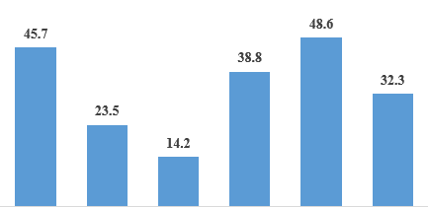
Your task is to sort these marks in ascending order. Perform this task using 1D-Array. You can use any sorting algorithm.
Sample Output:
Sorted array of marks : 14.2, 23.5, 32.3, 38.8, 45.7, 48.6
OR
You are given a 2D-Array of int datatype having 5 rows and 5 columns. Your task is to write a C++ program that calculates the sum of the highlighted colums and then subtract the sum of column 5 from column 1.
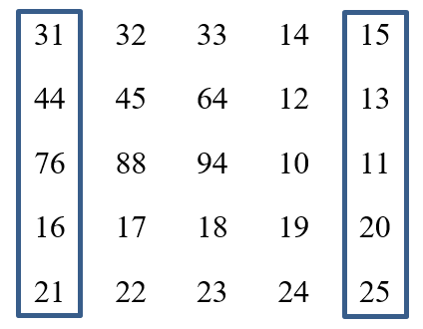
Sample Output:
Sum of column 1 is : 188
Sum of column 5 is : 84
Difference of column 1 and 5 is : 104
- Pointers and Functions (8 Marks)
Write a C++ program that prompts the user to enter a string. The program should then calculate and display the length of the entered string using pointer arithmetic. Utilize a function named calculateStringLength that takes a pointer to the string as a parameter and returns the length of the string.
Sample Output:
Enter any string: I love programming
Length of I love programming is 18
- Structures (6 Marks)
Write a C++ program that utilizes structures to manage student information. Define a structure named Student with data members for the student's name and an array representing marks in three subjects.
In the main fuction initialize an array of Student structures for two students. Take input from the user for the name and marks for each student. Calculate average marks of the student. Display the student's name and the calculated average marks for each student. Utilize appropriate loops for input and output.
Sample Output:
Enter student 1 name : Hamad
Enter subject 1 marks : 67
Enter subject 2 marks : 87
Enter subject 3 marks : 59
Enter student 2 name : Waqar
Enter subject 1 marks : 57
Enter subject 2 marks : 49
Enter subject 3 marks : 63
Student Name: Hamad
Average Marks: 71
Student Name: Waqar
Average Marks: 56.3333
- File Handling (6 Marks)
Write a C++ program that allows the user to enter student information, including their name and SAP ID. The program should store this information in a file named "info.txt". After entering each student's information, the program prompts the user whether they want to enter information for another student. The program continues to run until the user decides not to enter any more student information. Additionally, after the user decides not to add more student information, the program should read and display the contents of the "info.txt" file, showing the stored information for all the entered students.
Sample Output:
Enter Student Name: Shabana
Enter Student SAP ID: 704829
Data saved
Do you want to enter another student? (y/n): y
Enter Student Name: John
Enter Student SAP ID: 7038492
Data saved
Do you want to enter another student? (y/n): n
Reading data from file
Name: Shabana
SAP ID: 704829
Name: John
SAP ID: 7038492

- Loop (4 Marks)
In mathematics, the Triangle Inequality Theorem states that the sum of the lengths of any two sides of a triangle must be greater than the length of the third side. Write a C++ program that takes input for the sides of a triangle using a do-while loop. The program should continue to prompt the user for input until they enter valid side lengths that satisfy the Triangle Inequality Theorem. Finally, find the perimeter of the triangle and display it.

~ ~ ~ END ~ ~ ~

